Opening Dialogue
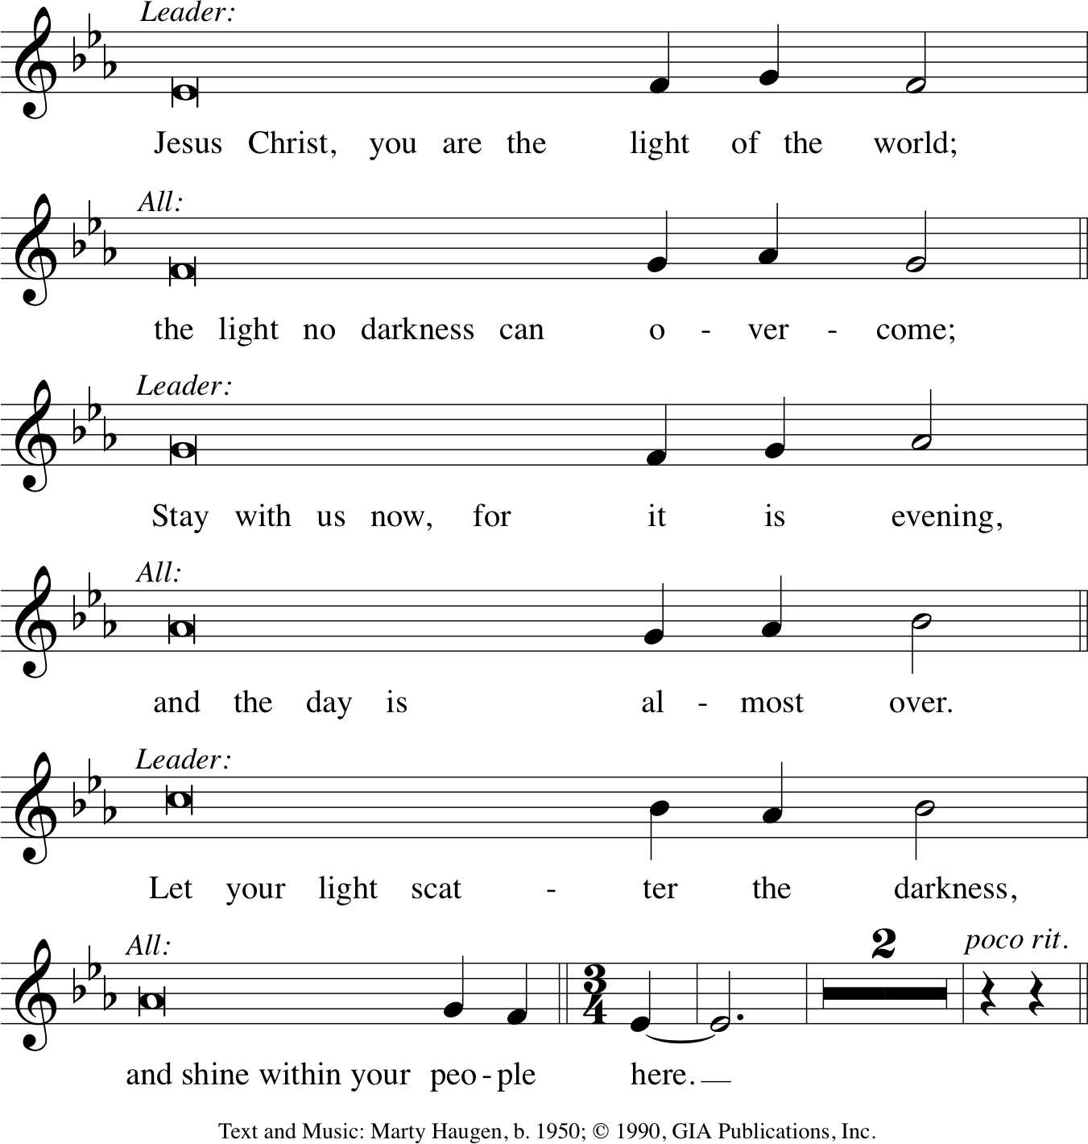

Evening Hymn
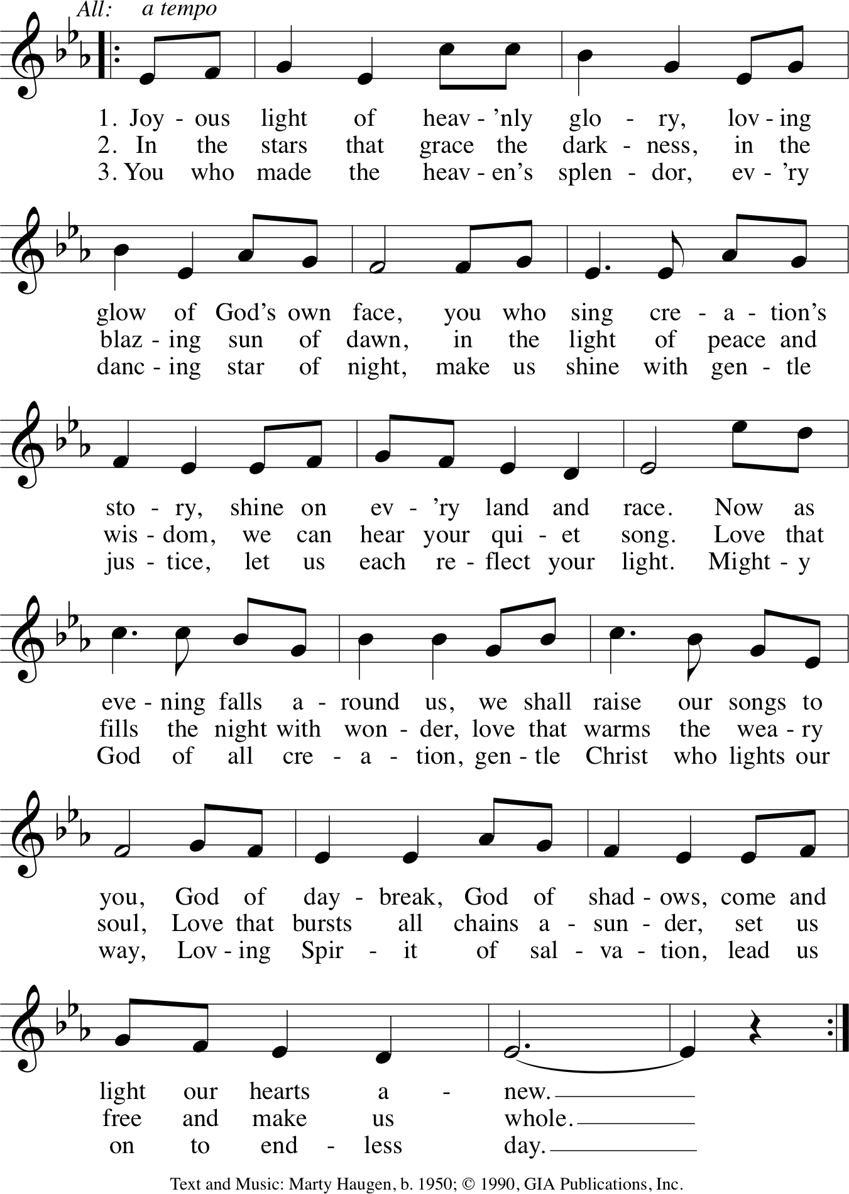
Evening Thanksgiving
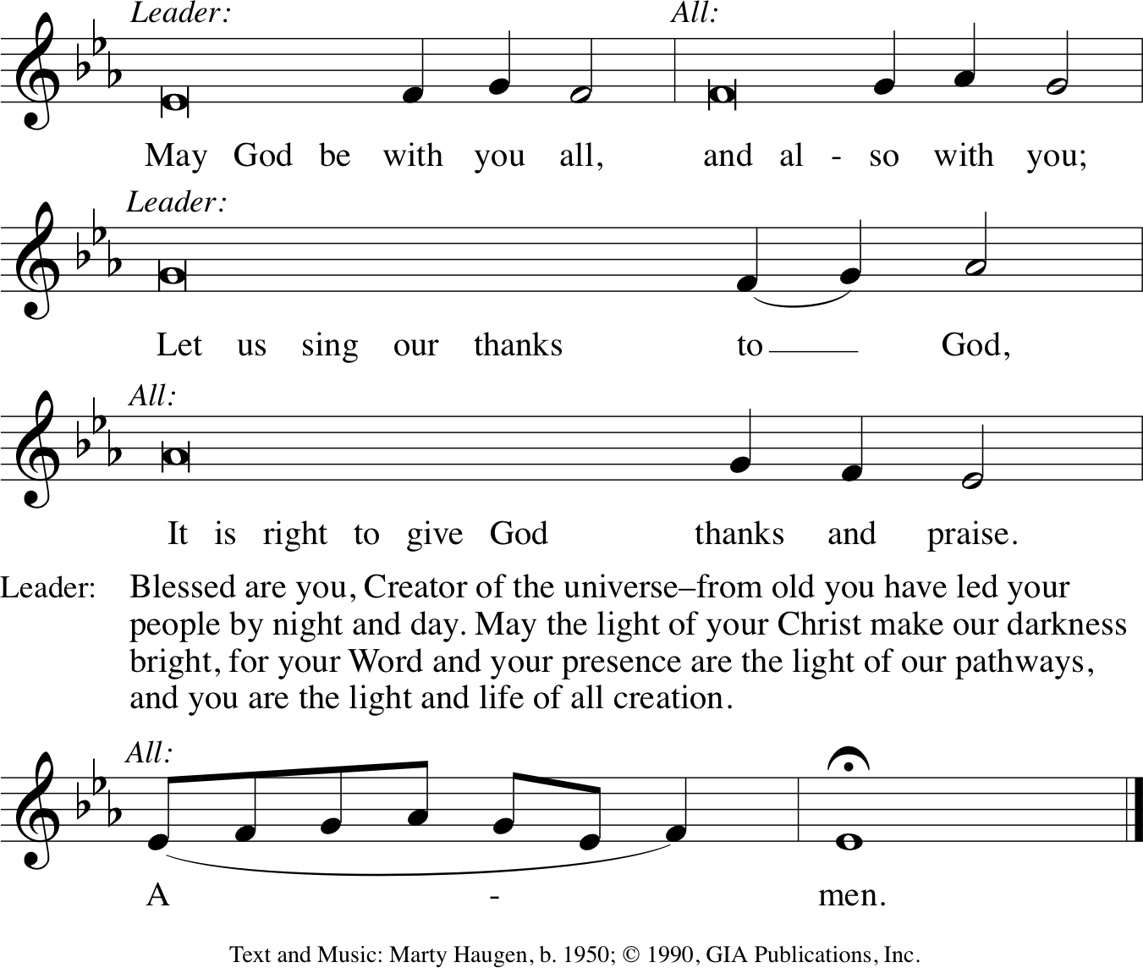

Psalm 141
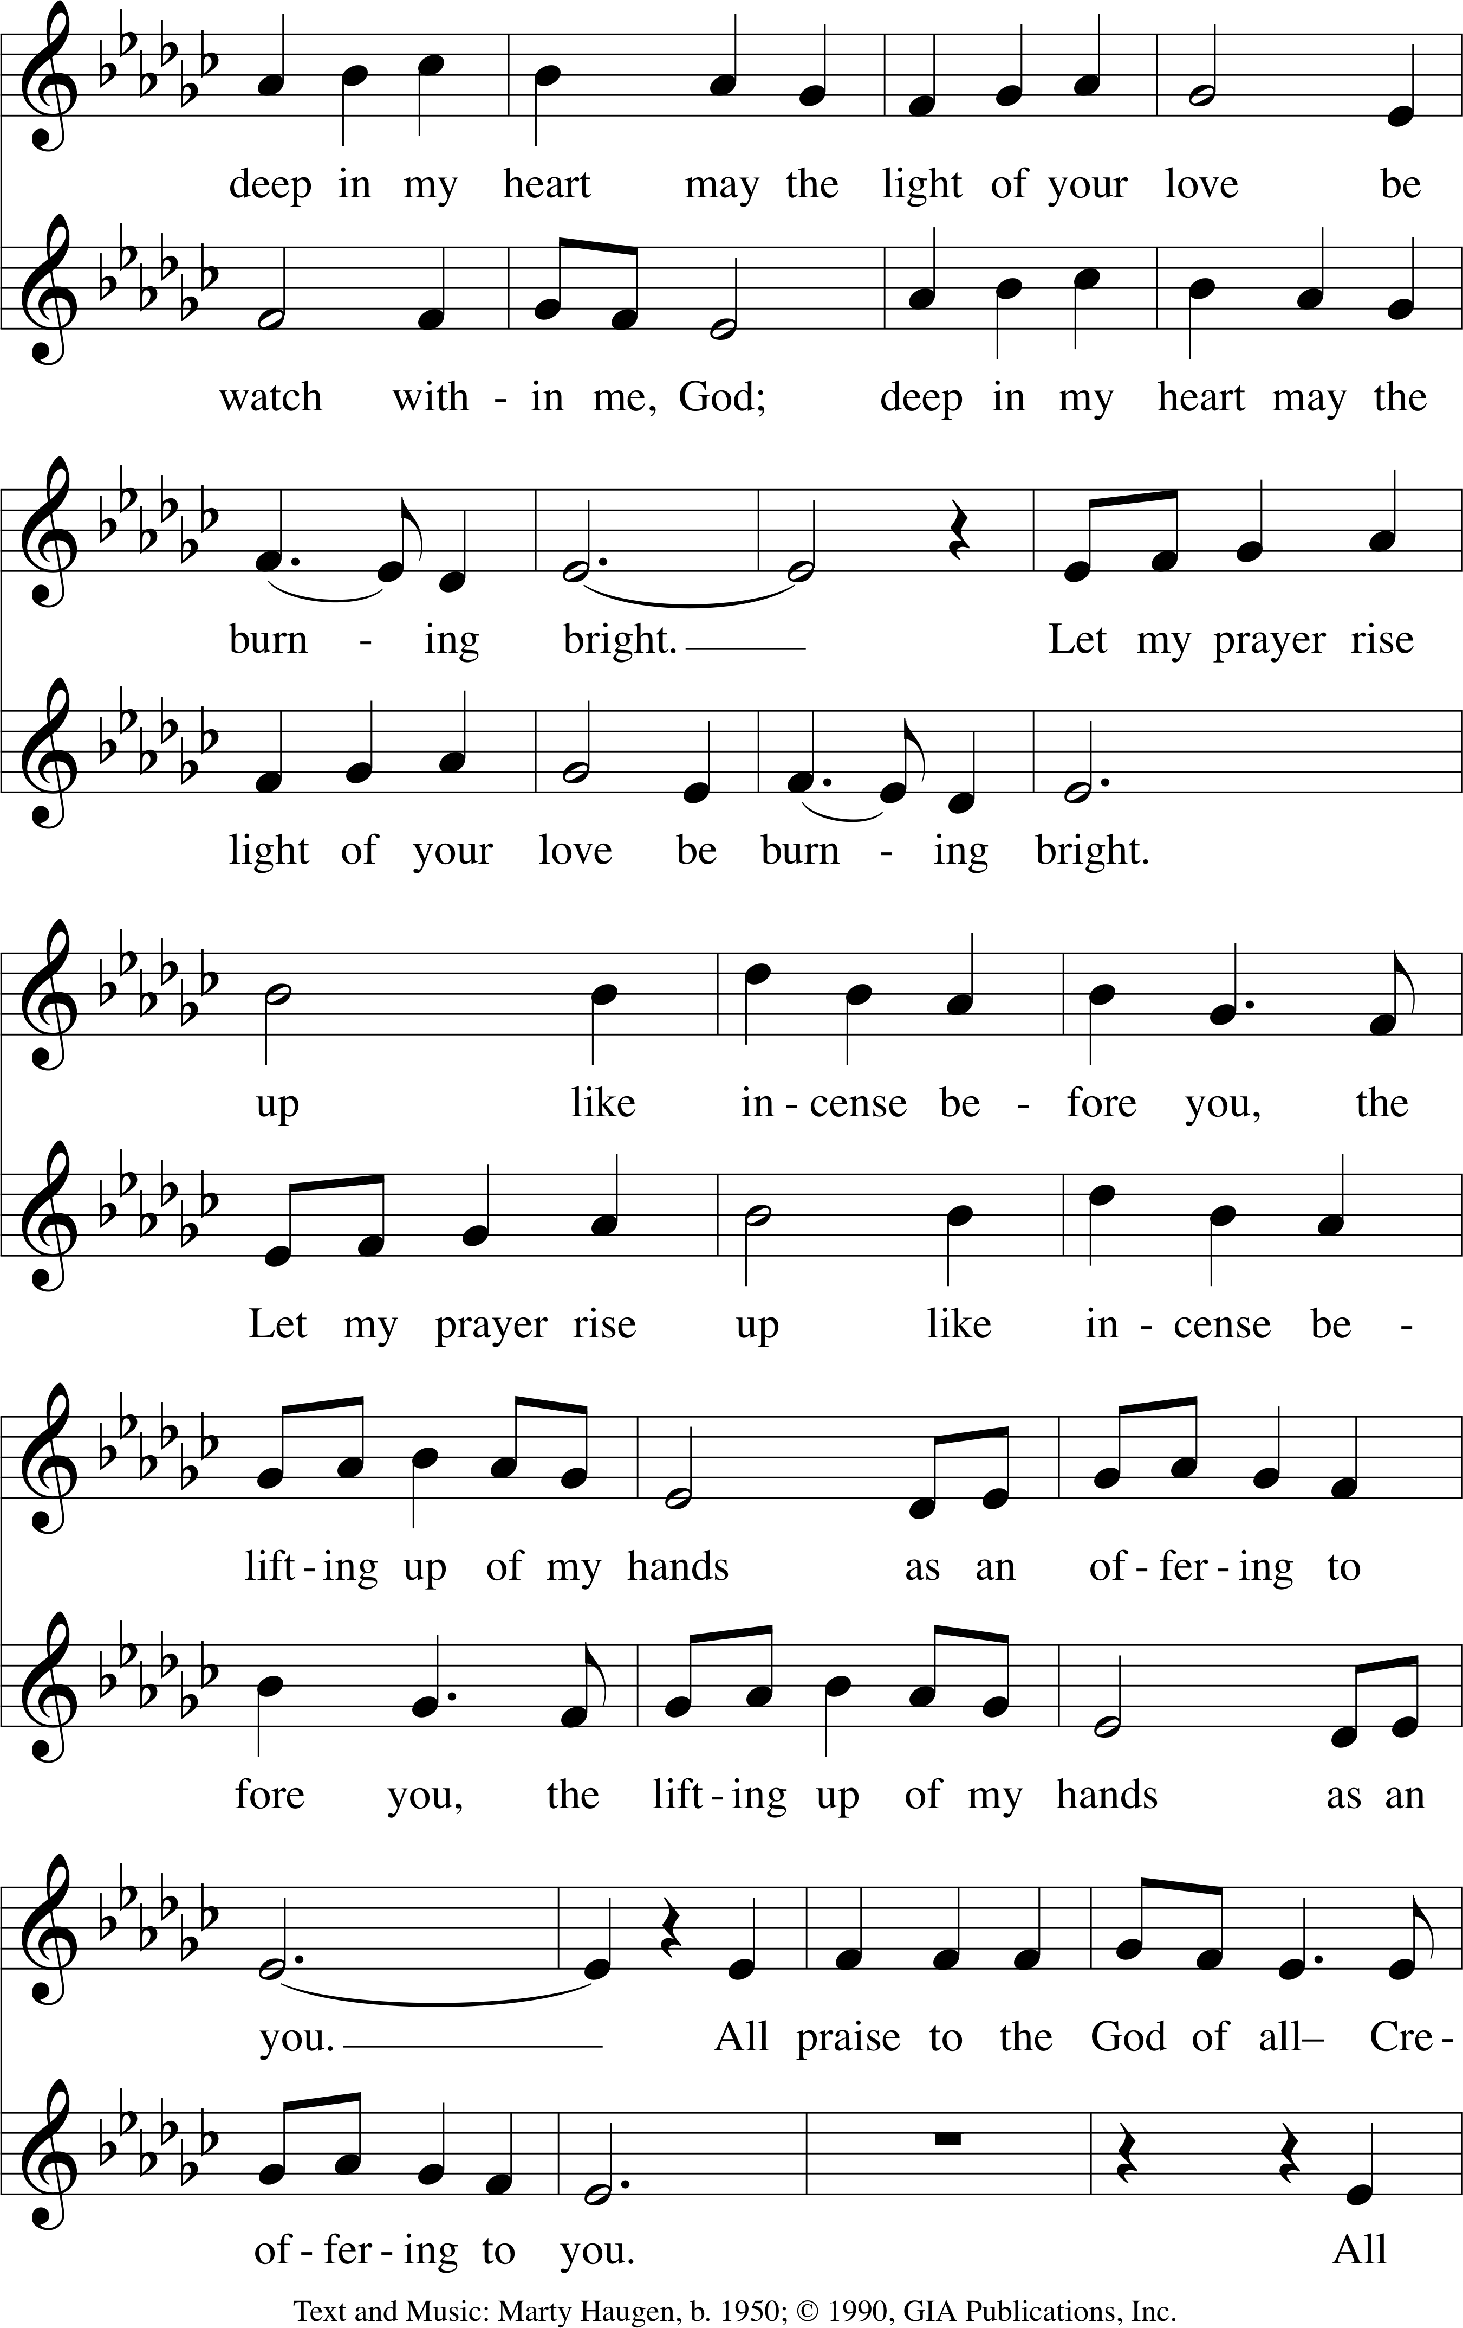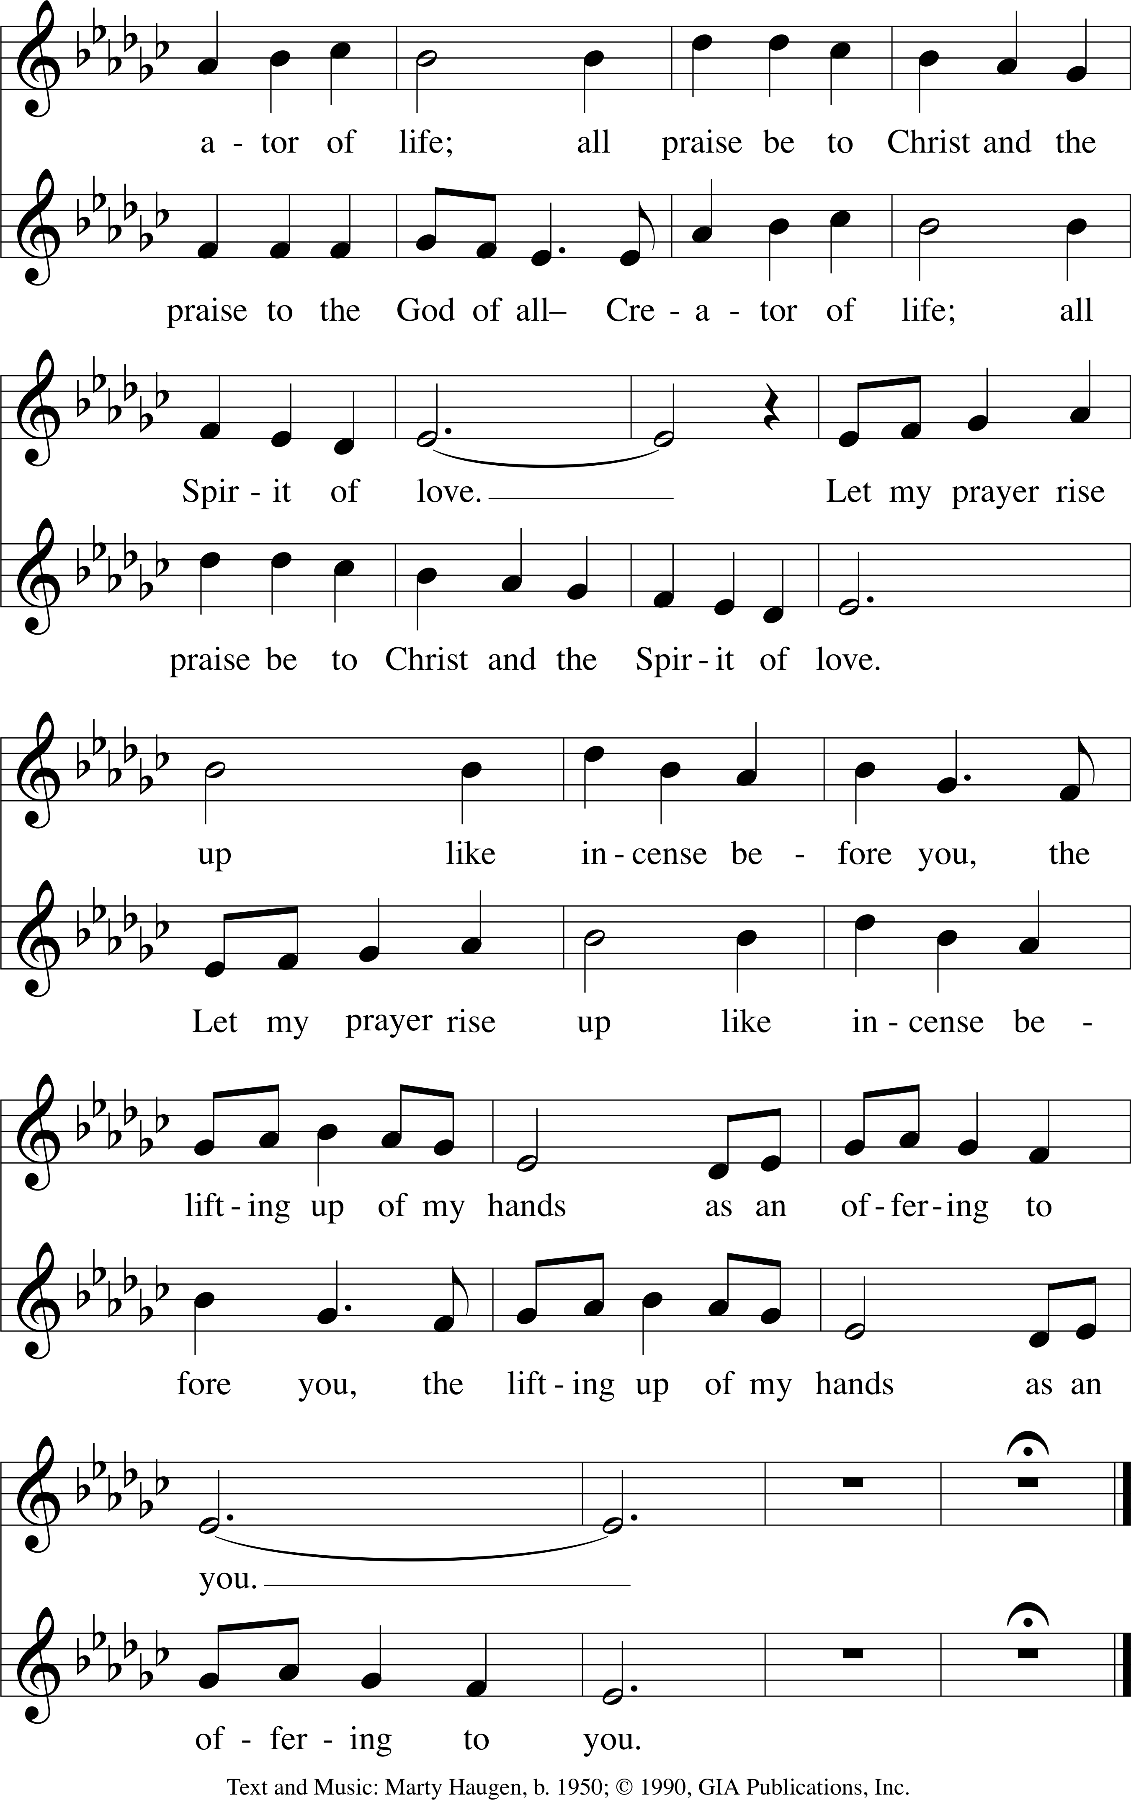

Silence for meditation

May our prayers come before you, O God, as incense, and may your presences surround and fill us, so that in union with all creation, we might sing your praise and your love in our lives. Amen.

Scripture Reading
- Feb 24—Matthew 4:1-11
- Mar 3—John 12:36-43
- Mar 10—Mark 11:15-19
- Mar 17—John 8:12-20
- Mar 24—John 12:34-50
The Light shines in the darkness and the darkness has not overcome it.

The Annunciation (Luke 1:26–28, 30–32, 38)
An angel went from God to a town called Nazareth to a woman whose name was Mary. The angel said to her, “Rejoice, O highly favored, for God is with you. You shall bear a child, and his name shall be Jesus, the Chosen One of God Most High.” And Mary said, “I am the servant of my God, I live to do your will.”

The Magnificat (Luke 1:46-55)
continued on next page
continued from previous page

Prayers

Great and merciful God, Source and Ground of all goodness and life, give to your people the peace that passes all understanding, and the will to live your Gospel of mercy and justice, through Jesus Christ our Lord. Amen.

God, remember us in your love, and teach us to pray:
Our Father in heaven, hallowed be your name. Your Kingdom come: your will be done on earth as in heaven. Give us today our daily bread. Forgive us our sins as we forgive those who sin against us. Save us from the time of trial, and deliver us from evil. For the Kingdom, the power, and the glory are yours, now and forever. Amen.
Final Blessing

Peace

